Game title:

ExorFist
(most of these things are subject to change)

This game design document consists of multiple pages and an extensive overview of each mechanic.
(or at least it eventually will)

TABLE OF CONTENTS
1.1 - The main page (You’re here!)
1.2 - Game Summary (Gameplay)
1.3 - Game Summary (Story)
1.4 - Game Glossary (Game terms)
1.5 - Game Controls
1.6 - Game UI + Mockups

2.1 - Planned Features & Game Mechanics
2.2 - Gameplay Bullet Points
2.3 - Gameplay : Combat
2.4 - Player Perspective

3.1 - Graphics and Artstyle

4.1 - Missions

5.1 - Enemies

6.1 - Bosses

7.1 - Progression (In-game progression) & Gameplay goals
7.2 - Chi (Skill & Player XP)
7.3 - Meditation
8.1 - Current Gamestate
9.1 - Story
9.2 - Setting

1.2 Game Summary (Gameplay)

Cross-breed between Sifu combat mixed with an ability system.
Abilities in this game are martial arts maneuvers with a mystic element tied to them. Unarmed combat is a mainstay.

Beat Em Up gameplay with a focus on counter-attacking and throwing the enemy off “balance”, thus allowing you to start a visceral offense.
Currency and upgrade-based progression. Gain chi from defeating yaoguai and use them to upgrade yourself.
True mastery can only be achieved by spending time with your master and deepening your bond with him through meditation. Meditation acts as a gateway to unlock new moves as well as training with your shifu in order to practice these moves.
3D Brawler, think Yakuza or Sifu like mentioned before.

Yakuza Gameplay Image
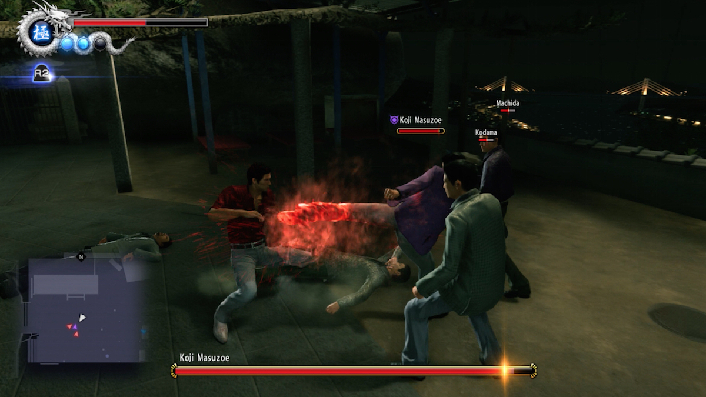
Sifu Gameplay Image
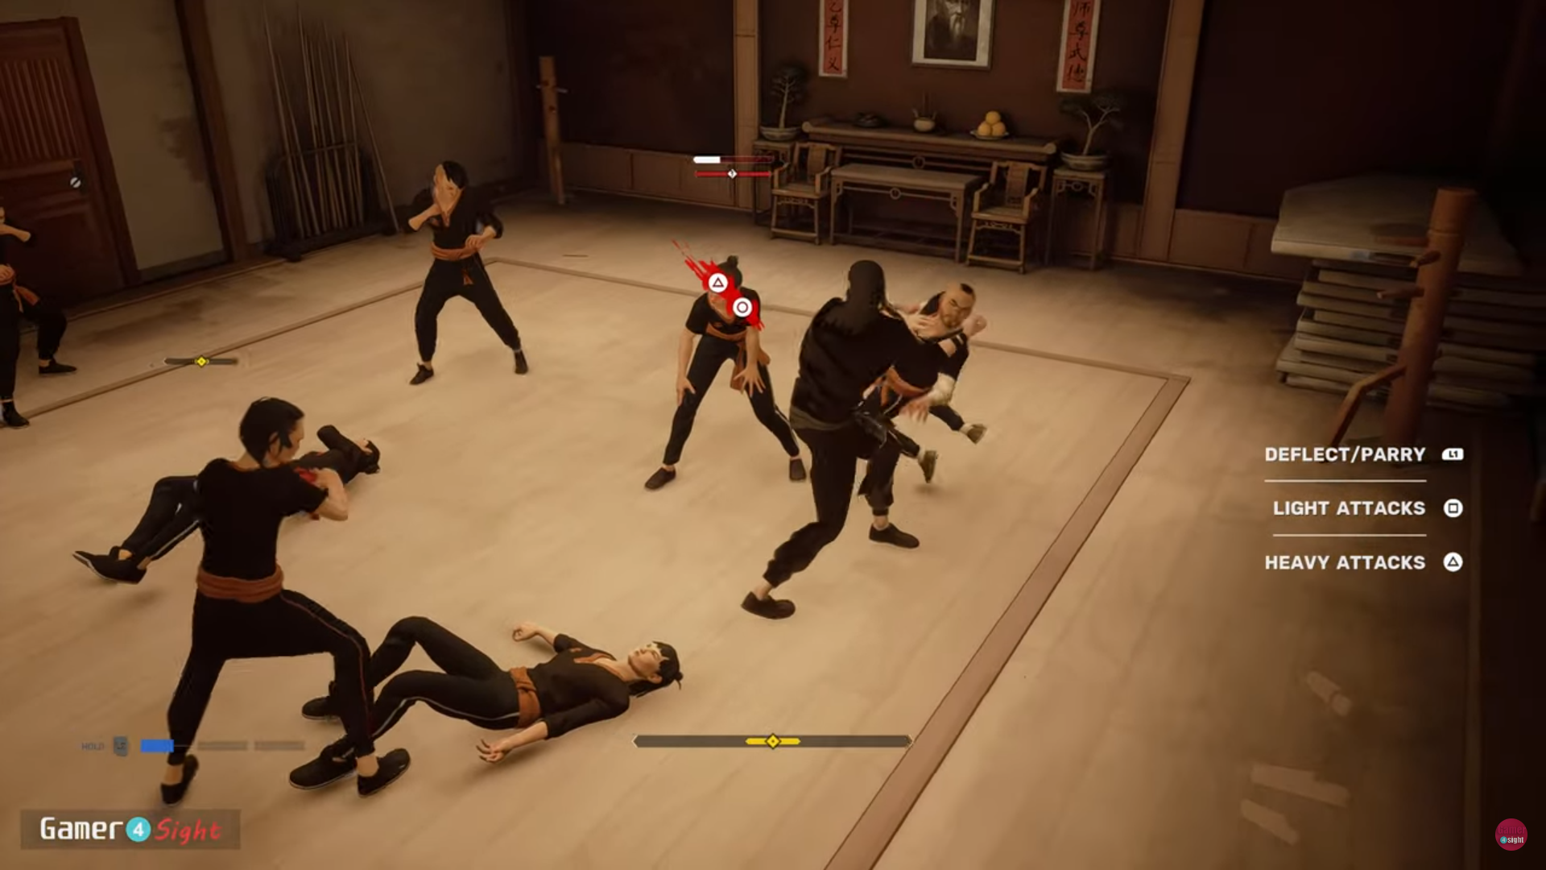

1.3 Game Summary (Story)
Guo Yong. The legendary delinquent. The name alone is enough to send terrors through any highschooler within Héxié city.

The troublemaker has garnered a reputation for being undefeatable within street brawls. Some say that he attacks with the strength of a demon, he has earned the moniker of “Dragon Delinquent” for his trademark jacket; A dark teal jacket with green accents, adorned with a scale-like pattern and a dragon emblazoned on it’s back.

Truth be told, Guo Yong is actually just trying to do his best. He has no parents to speak of and only lives for his best friend’s wellbeing. As such he does everything in his power to make sure their life sails as smoothly as possible.

Unfortunately, he would lose his best friend to an unfortunate and horrific happenstance.

He and his best friend would be caught in an encounter. He loses them to a yaoguai, a demonic monster with mystic origins only heard of from folk tales, but he gets saved by a stranger who proclaims to be a martial exorcism master.

After being saved from the yaoguai. The shifu takes in Guo Yong and he begins his journey of realizing his potential through martial mastery in the way of the ExorFist.

Training under the tutelage of his new master, Guo Yong soon discovers he has a natural talent for exorcising yaoguai by utilizing his combat acuity and martial exorcism lessons , although he still has a long road ahead of him.

Play as him as you clear through the streets of Héxié city at night and rid the city of monsters, while discovering more about the world and how these yaoguai came to be in the first place.

1.4 Game Glossary

This glossary contains a list of keywords used to describe mechanics in our games, in order to maintain consistency and clarity both for the player and also ourselves while throughout development.

Progression Mechanic Terms

Mission - The actual “gameplay area” the player is situated in, the player completes the mission to progress the story as well as unlock further missions until the end of the game.

Chi - A resource that’s used to purchase new attacks and abilities. Spent where your shifu resides, meditating with him allows you to purchase new abilities.

Meditation/Meditate - The interactive part that opens up a new menu for the player to navigate. This menu acts as the metaphorical “shop” the player spends their Chi at.

Combat Mechanic Terms

Health - It’s health. Take damage, lose health, health goes to 0. Whatever has the health dies.

Light Attack - Low commit attack and mapped to “button1”. Can be pressed up to three additional times for a chained attack.

Heavy Attack - High commit attack and mapped to “button2”. Cannot be animation canceled. Deals more damage than the light attack.

Startup Frames - The animation frames of an attack animation where the player is able to animation cancel if the player chooses. Can only animation cancel into a dodge or a block.

Low-commit - A tag applied to specific abilities and attacks, the player can animation cancel out of these moves and transition into another move if needed. Specifically a block move, a parry, or an ability.

High-commit - A tag applied to specific abilities and attacks. The player CANNOT animation cancel out of these moves.

Animation Cancel - Another tag applied to specific abilities and attacks. Animation cancelling means the player is not locked into a specific animation ( whether it be blocking, attacking or parrying ) and can quickly transition into another move.

Block - A move that both the player and enemies can use. Prevents users from taking damage from an attack, at the cost of reducing balance upon receiving an attack.

Balance - A resource used by the player in order to continue blocking. If the player blocks while their balance is empty, their block will break and they will not block the next attack they receive. Parrying an attack will restore balance to the player as well as breaking the balance of an enemy.

2.1 Planned Features & Game Mechanics
- Mission select, go through different districts of Héxié by selecting it on the map and fight your way through to the end of the level.

- Upgrade system to empower Guo Yong by using collected Chi from exorcising yaoguai. Speaking to Guo Yong’s shifu will give him the option to “meditate” with him, allowing Giving Guo Yong to spend his chi to acquire more combat moves to use, while also deepening his bond with his shifu. (Upgrade system can be excluded from development until the rest of the mechanics are done)

- Move List to allow the player to view their unlocked moves.

2.2 Gameplay: Bullet Points
3D Auto Lock-on combat, Sifu-esque and Batman : Arkham Asylum like combat, the player always faces the closest enemy and their attacks will naturally gravitate towards enemies towards a movement input.

The camera can be controlled by the player, but is also controlled by the game during fights, keep this in mind, which means the programmers need to find a solution to help give the player the best view of the fight while maintaining combat fluidity.

There is no button to control the camera, the player would simply need to touch the screen to control it.

This means that the camera only gets controlled by the player once they enter combat and detect an enemy. After which the camera focuses on the fight and control is taken away from the player in regards to the camera.
- Health bar
- Abilities and Cooldowns
- Light attacks and heavy attacks
- Both player and enemies can block
- Guo Yong can parry if he blocks an attack with perfect timing
- Animation canceling
- Motion inputs for different attacks
- Combos
- Combo counter for scoring purposes
- Enemies (and Guo yong) have a “balance” meter, which, when broken, will allow the player to start their offense again. This puts enemies into a stunned state, resetting your ability cooldowns and allowing you to pressure them with offense again.

2.3 Gameplay : Combat

As a martial exorcism student, Guo Yong is able to fend off various yaoguai (monster) using martial arts techniques as well as street fighting acuity.

Combined with his chi manifesting as a visage of rain, Guo Yong swifts through combat like a storm, fluid as water and as hard as a thunderclap.

You, the player, are able to use many tools at your disposal.

Health
You have health. Take damage, lose health. Health reaches zero, you lose the game. It is visually represented in the top left as a health bar.

Blocking
Blocking prevents damage that you might take. Causing your spiritual energy to manifest as a barrier, however take care as you cannot block forever.

Balance
Another “health” mechanic of sorts, but it acts as the health of your block.
Blocking attacks for too long will cause your balance to be affected, once your balance is completely depleted, your block will break, causing Guo Yong to recoil, leaving him open to take an unfortunate hit.

3.1 Graphics
(and stuff related to visuals)
It’s a 3D Game.

Similar to Sifu and Absolver. Stylised models, atmospheric and dark.

Colour scheme and general setting can be considered “Dark Fantasy” but with a Chinese mysticism twist. So a lot of dark blues and red.
Painterly-style textures that look very story bookish.
Example images below
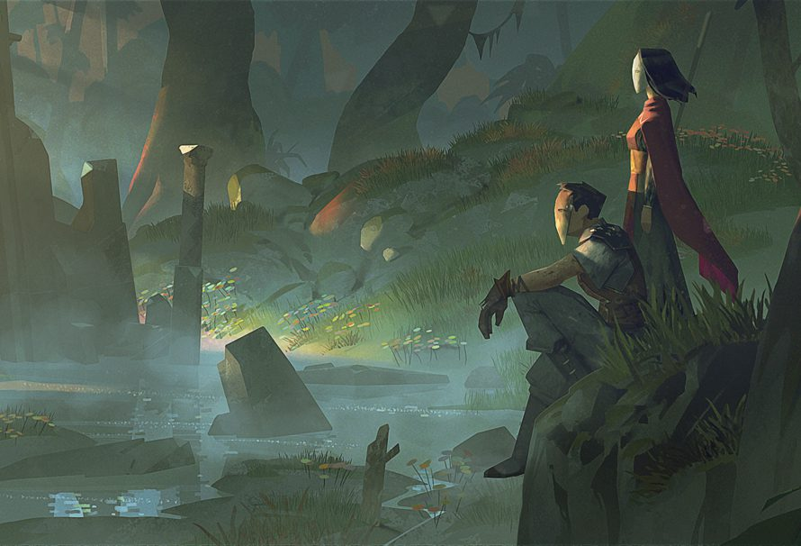
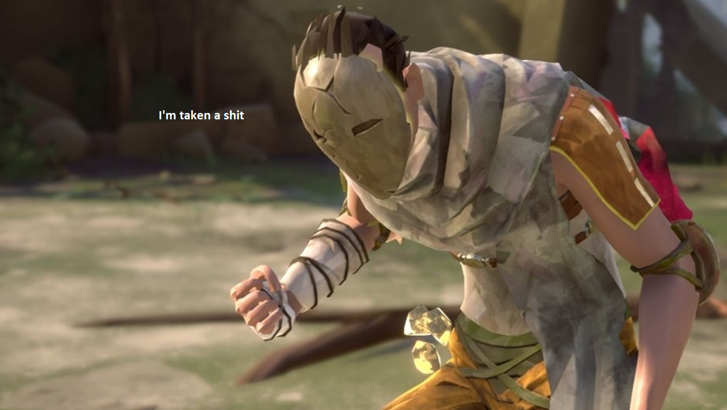
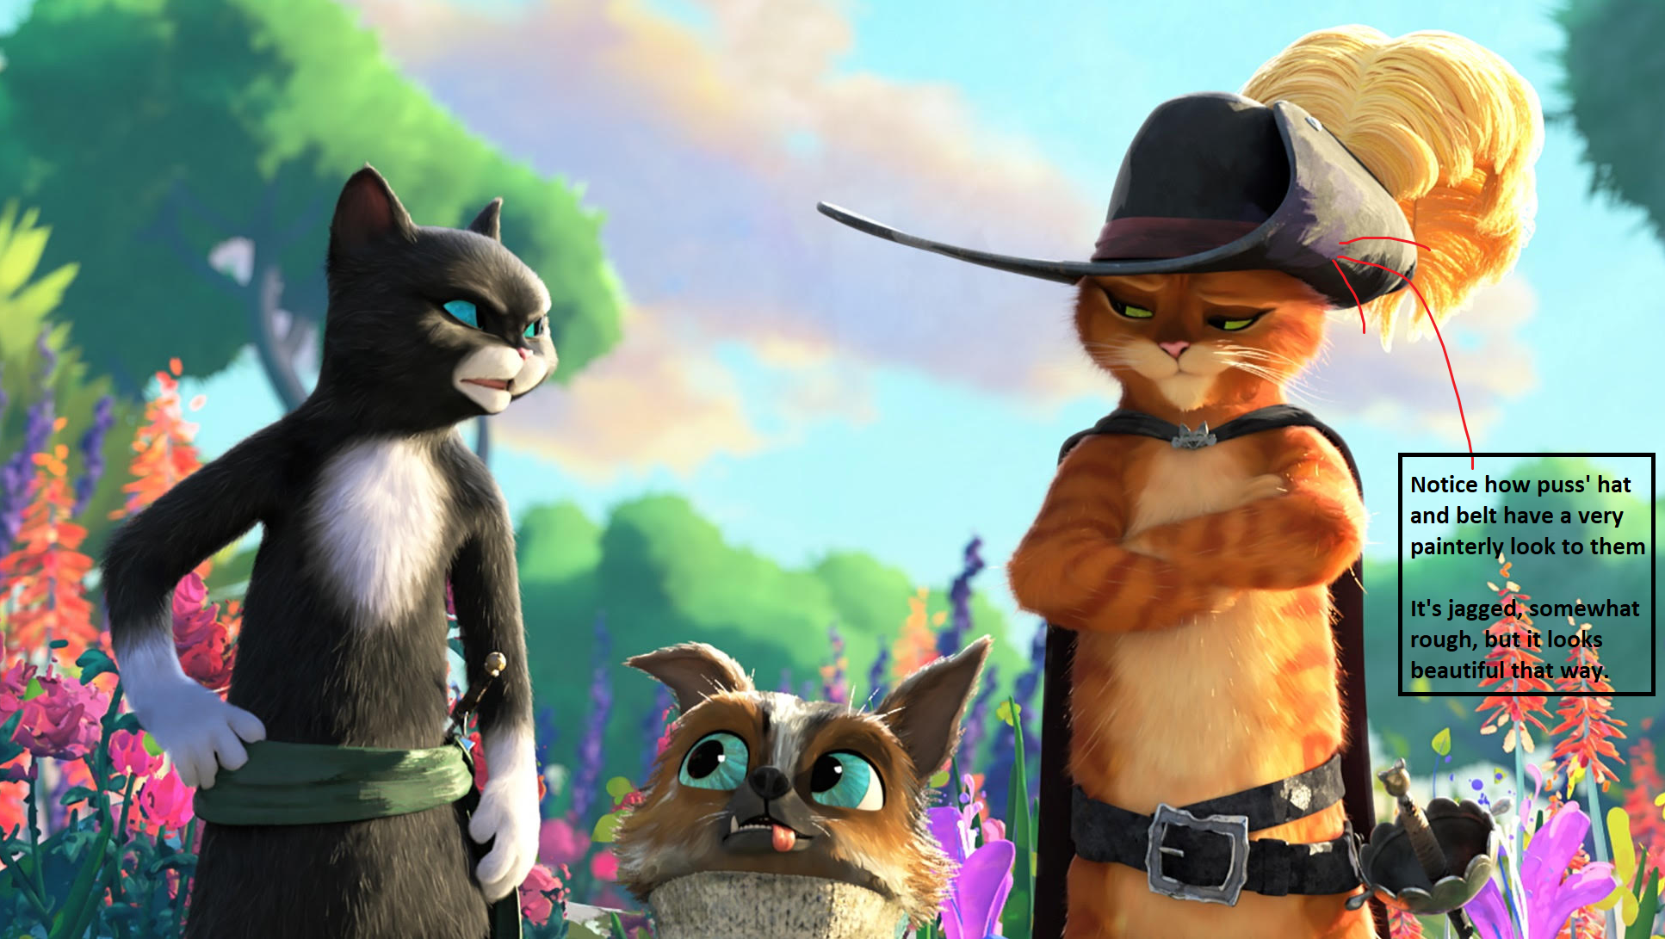
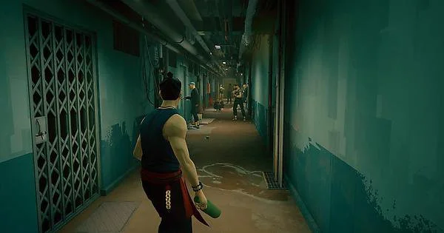
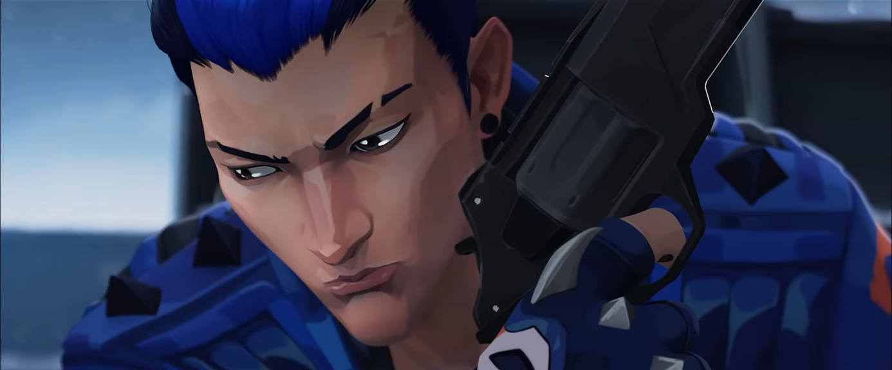

3.2 Visual feedback and visual effects
Visual feedback is important as it necessitates and elevates the current action taking place within the game-world. A good way to add some extra “oomph” to a scene/action is visual effects, as well as impact frames.

CHARACTERS and anything of mild interest gameplay wise will have a slight sobel lighting effect applied (which can look like rim lighting) as well as the usual outline the player also has. This makes it stand out organically while maintaining the stylised look.

An example is provided above with the puss in boots stuff, and also below.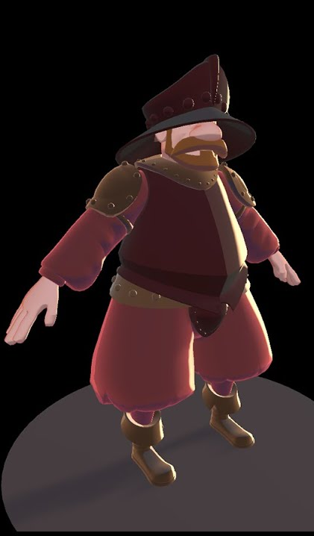
4 Missions
This section consists entirely of the list of areas. They will be expanded upon in 4.3 and onwards of the document. Firstly, let’s try and get the first stage done.

After each main “combat” portion, they enter the next hub section. There is of course the starting hub section.

5.1 Enemies

6.1 Bosses

7.1 Progression

There are two main methods of progression in ExorFist

-Player progression via purchasable upgrades using Chi.
-Narrative/Mission progression by completing the stage and getting to the end.

7.2 Chi

The game is centered around exorcising yaoguai, this is done by brutalising them and beating them up of course!

When enemies perish, they drop chi, chi is used to upgrade Guo Yong and is spent when meditating with his shifu.
At the moment, the only planned upgrades would be unlocking new attacks and new abilities.

Tougher enemies drop more chi etc. you get the point, it’s just darkness from Hades.

It would look very ephemeral and smokey, kind of like the vfx that plays when you perish in Dark Souls, where your character sort of dissipates and scatters like dust upon death.

An example of how it would look like is shown below
(the doc ends here sorry)

